|  |
| --- |
| Hiveboard.ca |
| DroneBoard |
| Version 1.0 |

|  |
| --- |
| 3-11-2023 |

Contents

DroneBoard Layout 2

DroneBoard Wiring 1

HiveBoard Connector 1

I2C Connectors 1

Drone Outputs 1

Isolated EZO™ Sensor Connector 1

Non-Isolated EZO™ Connector 1

JST-SH Connector 1

Isolated EZO™ Sensor Connector 2

Non-Isolated EZO™ Connector 2

DroneBoard Basic Layout 3

DroneBoard Basic Wiring 3

HiveBoard Connector 3

I2C Connector 3

Drone Outputs 1

## DroneBoard Layout

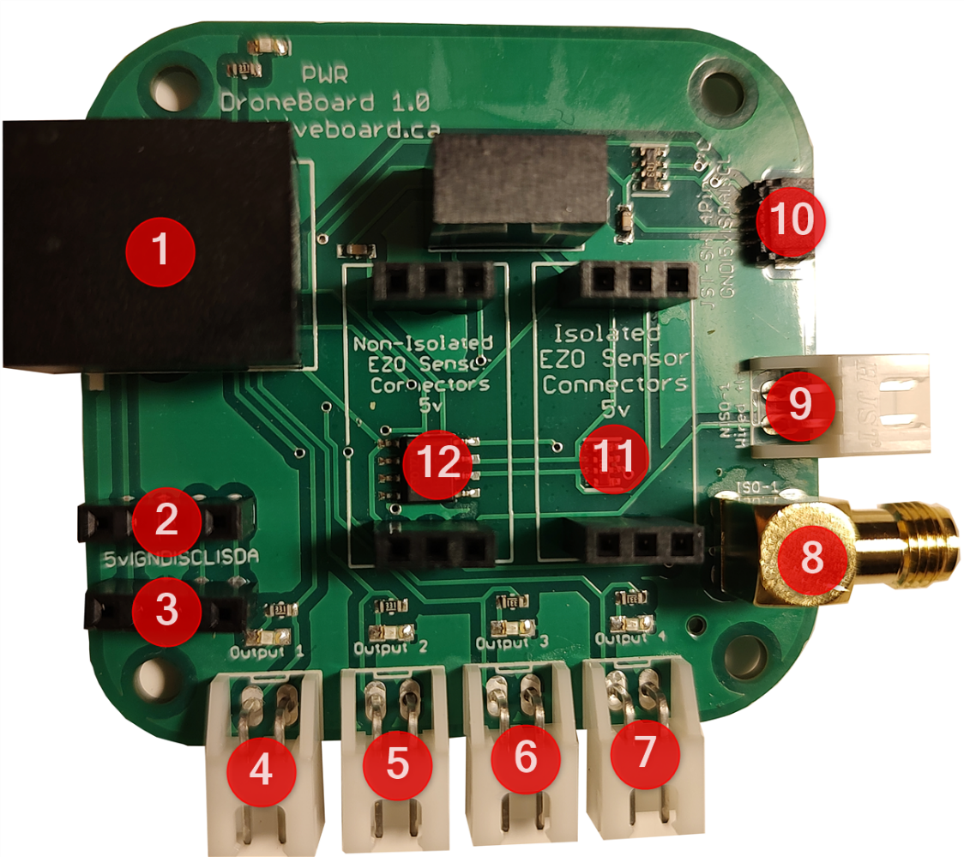

1. HiveBoard Connection

2-3. I2C Connection

4-7. Drone Outputs

8. Isolated EZO™ Sensor Connector

9. Non isolated EZO™ Probe Connector

10. JST-SH Connector

11. Isolated EZO™ Sensor Connector

12. Non-isolated EZO Sensor™ Connector

The DroneBoard is designed to be connected to the HiveBoard through the DroneBoard connectors. It can also be used as a mini EZO™ sensor holder. To do this one needs to provide power through the I2C connections.

## DroneBoard Wiring

### HiveBoard Connector

Labelled as #1 on the DroneBoard Layout diagram

One can use a standard ethernet cable to connect the DroneBoard to the HiveBoard. If one is making their own breakout board, the wiring of the Drone connectors is as below. All outputs run at ~9.5V when connected to the HiveBoard

|  |  |
| --- | --- |
| 1. SCL | 5. 5V |
| 2. Output 4 | 6. Output2 |
| 3. SDA | 7. GND |
| 4. Output3 | 8. Output 1 |

### I2C Connectors

Labelled as #2-#3 on the DroneBoard Layout diagram

|  |  |
| --- | --- |
|  | Wired as 5V/GND/SCL/SDA |

### Drone Outputs

Labelled as #4-#7 on the DroneBoard Layout diagram

|  |  |
| --- | --- |
|  | Wired as (VDD/GND)  Each output has a LED that activates when turned on |

### Isolated EZO™ Sensor Connector

Labelled as #8 on the DroneBoard Layout diagram

|  |  |
| --- | --- |
|  | Standard SMA connector |

### Non-Isolated EZO™ Connector

Labelled as #9 on the DroneBoard Layout diagram

|  |  |
| --- | --- |
|  | Wired as (VDD/GND) |

### JST-SH Connector

Labelled as #10 on the DroneBoard Layout diagram

|  |  |
| --- | --- |
|  | Wired as (SDA/SCL/5V/GND) |

### Isolated EZO™ Sensor Connector

Labelled as #11 on the DroneBoard Layout diagram

|  |  |
| --- | --- |
|  | Runs at 5v  Designed For:  Atlas Scientific EZO™ pH Sensor  Atlas Scientific EZO™ ORP Sensor  Atlas Scientific EZO™ Electrical Conductivity Sensor  Atlas Scientific EZO™ Dissolved Oxygen Sensor  Atlas Scientific EZO™ Temperature Sensor  Atlas Scientific EZO™ Flow Totalizer |

### Non-Isolated EZO™ Connector

Labelled as #12 on the DroneBoard Layout diagram

|  |  |
| --- | --- |
|  | Runs at 5v  Designed For:  Atlas Scientific EZO™ Temperature Probe  Atlas Scientific EZO™ Flow Totalizer |

## DroneBoard Basic Layout

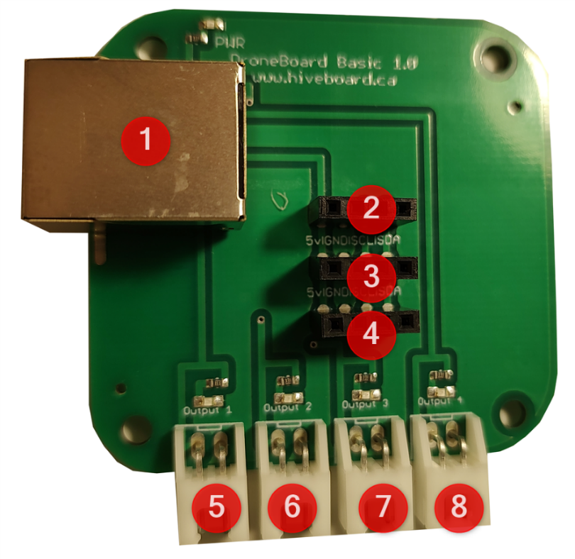

1. Connection from HiveBoard

2-4. I2C Connection

5-8. Drone Outputs

## DroneBoard Basic Wiring

### HiveBoard Connector

Labelled as #1 on the DroneBoard Basic Layout diagram

One can use a standard ethernet cable to connect the DroneBoard to the HiveBoard. If they are making their own breakout board, the wiring of the Drone connectors is as below. All outputs run at ~9.5V when connected to the HiveBoard

|  |  |
| --- | --- |
| 1. SCL | 5. 5V |
| 2. Output 4 | 6. Output2 |
| 3. SDA | 7. GND |
| 4. Output3 | 8. Output 1 |

### I2C Connector

Labelled as #2-#4 on the DroneBoard Basic Layout diagram

|  |  |
| --- | --- |
|  | Wired as 5V/GND/SCL/SDA |

### Drone Outputs

Labelled as #5-#8 on the DroneBoard Basic Layout diagram

|  |  |
| --- | --- |
|  | Wired as (VDD/GND) |